Declaration of Conformity (DoC)

We,Shenzhen DOKE Electronic Co.,Ltd.

801, Building3, 7th Industrial Zone, Yulv Community, Yutang Road, Guangming District, Shenzhen, China.

Declare that the DoC is issued under our sole responsibility and belongs to the following product(s): Product Type: Mobile Phone
Trademark： Blackview
Model Number(s): BV4800 Pro

(Name of product, type or model, batch or serial number) System components:
PIFA Antenna:BT/Wi-Fi2.4G:0.66dBi; WIFI5G:0.62dBi;
GSM900:-2.85dBi/DCS1800:0.91dBi; WCDMABandⅠ: 0.21dBi,BandⅧ:-2.96dBi; LTE: B1: 0.68dBi; B3: 0.88dBi; B7: 0.95dBi; B8: -2.76dBi;
B20: -3.26dBi; B28: -3.26dBi; B40: 0.21dBi; B41: 0.21dBi;

Adapter :
Model: HJ-0502000-EU
Input: 100-240V~50/60Hz 0.3A Output: 5.0V 2.0A 10.0W
Manufacturer: Shenzhen Huajin Electronics Co.,Ltd

RechargeableLi-ionBattery:
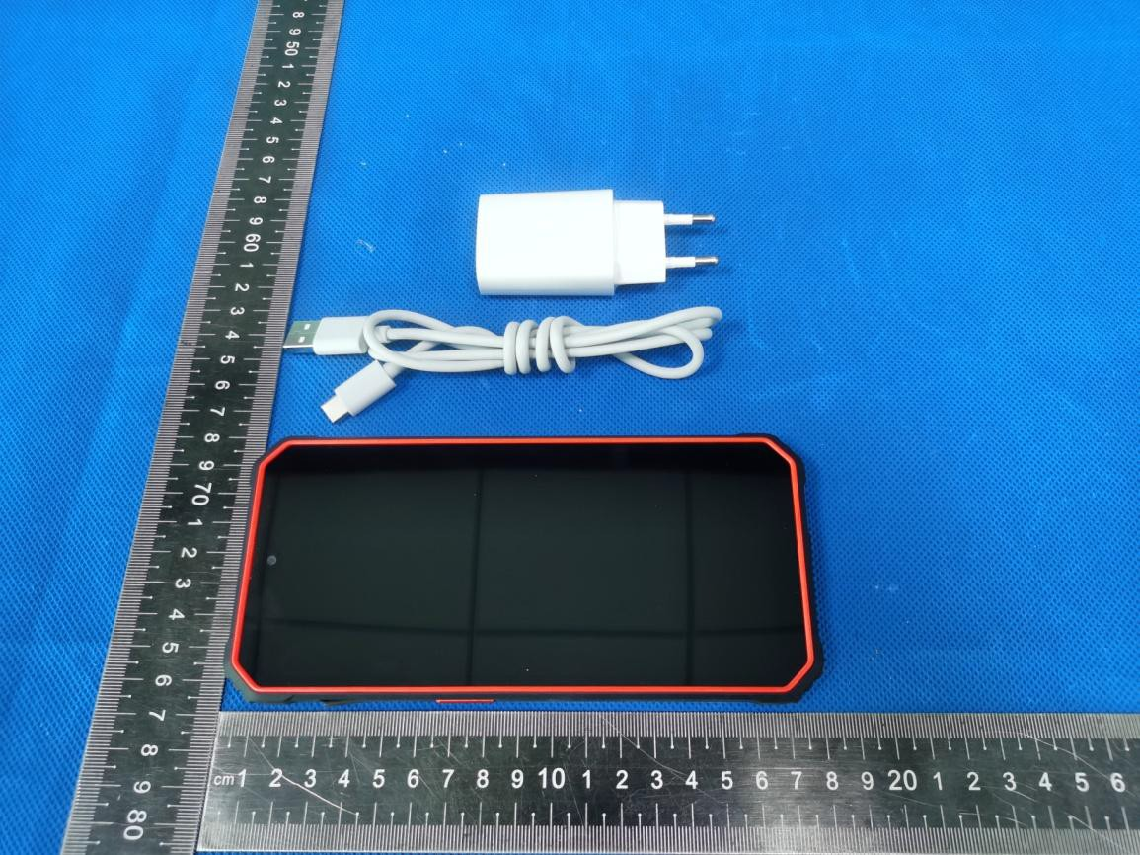Model:LiU516386PHTT; Specification: DC 3.85V, 5180mAh, 19.94Wh; Manufacturer:Shenzhen Huatiantong Technology Co.,Ltd.

The object of the declaration described above is in conformity with the essential requirements of the relevant Union harmonization legislation: Radio Equipment Directive RED (2014/53/EU).
The following harmonized standards and technical specifications have been applied:

HEALTH & SAFETY (Art. 3(1)(a)):

EN 50360:2017;

EN 50566:2017;

EN 62209-1:2016;

EN 62209-2:2010;

EN 62479:2010

EN IEC 62368-1:2020+A11:2020

EMC (Art. 3(1)(b)):

ETSI EN 301 489-1 V2.2.3 (2019-11)

ETSI EN 301 489-3 V2.1.1 (2019-03)

ETSI EN 301 489-17 V3.2.4 (2020-09)

ETSI EN 301 489-19 V2.2.1 (2022-09)

ETSI EN 301 489-52 V1.2.1 (2021-11) EN 55032:2015+A1:2020
EN 55035:2017+A11:2020

EN IEC 61000-3-2:2019+A1:2021 EN 61000-3-3:2013+A2:2021
Radio Spectrum (Article 3.2):

EN 301 511 V12.5.1 (2017-03);

EN 301 908-1 V15.1.1 (2021-09);

EN 301 908-2 V13.1.1 (2020-06);

EN 301 908-13 V13.2.1 (2022-02);

EN 300 328 V2.2.2 (2019-07);

EN 301 893 V2.1.1 (2017-05);

EN 300 330 V2.1.1 (2017-02)

EN 300 440 V2.2.1 (2018-07);

EN 303 413 V1.2.1 (2021-04);

EN 303 345-1 V1.1.1 (2019-06);

EN 303 345-3 V1.1.1 (2021-06);

Notified Body Involved:

Notified Body Name: Eurofins Electrical and Electronic Testing NA, Inc. Notified Body Number: 0980
Notified Body Assessment Performed: Module B/C on Article 3.1a, 3.1b, 3.2
EU-type examination certificate number: 3443-09-2024-240693

RF Specification:

Function | Operation Frequency | Max RF  outputpower:
BLE | 2402MHz–2480MHz | 2.17dBm
BT(BR+EDR) | 2402MHz–2480MHz | 6.37dBm
WIFI 802.11b/g/  n(HT20/40) | 802.11b/g/n(20MHz): 2412~2472MHz;  802.11n(40MHz):2422~2462MHz | 15.83dBm
Wi-Fi 5.2G(802.11a/n20/n4  0/ac20/ac40/ac80) | 802.11a/ n20/ac20:5180MHz~5240MHz  802.11 n40/ac40:5190MHz~5230MHz  802.11 ac80:5210MHz | 12.96dBm
Wi-Fi 5.8G(802.11a/n20/n4  0/ac20/ac40/ac80) | 802.11a/ n20/ac20:5745MHz~5825MHz  802.11 n40/ac40:5755MHz~5795MHz  802.11ac80:5775MHz | 11.72dBm
GSM/GPRS/EGPRS  900 | TX(Uplink):880M‐915MHZ;  RX(Downlink):925M‐960MHZ | 31.62dBm
GSM/GPRS/EGPRS  1800 | TX(Uplink):1710M‐1785MHZ;  RX(Downlink):1805M‐1880MHZ | 28.76dBm
WCDMA B1 | TX(Uplink):1920-1980MHz;  RX(Downlink):2110-2170MHz | 21.94dBm
WCDMA B8 | TX(Uplink): 880-915MHz;  RX(Downlink):925-960MHz | 22.38dBm
LTE FDD B1 | TX(Uplink):1920-1980MHz;  RX(Downlink):2110-2170MHz | 23.67dBm
LTE FDD B3 | TX(Uplink) :1710-1785MHz;  RX(Downlink):1805-1880MHz | 23.5dBm
LTE FDD B7 | TX(Uplink) :2500-2570MHz;  RX(Downlink):2620-2690MHz | 23.32dBm
LTE FDD B8 | TX(Uplink): 880MHz to 915 MHz  RX(Downlink): 925 MHz to 960 MHz | 24.29dBm
LTE FDD B20 | TX(Uplink): 832MHz~862MHz;  RX(Downlink): 791MHz~821MHz | 23.71dBm
LTE FDD B28 | TX(Uplink): 703MHz~736MHz;  RX(Downlink): 758MHz~791MHz | 23.65dBm
LTE TDD B40 | TX(Uplink)& RX(Downlink)  2300 MHz to 2400 MHz | 23.27dBm
LTE TDD B41 | TX(Uplink)& RX(Downlink)  2496 MHz to 2690 MHz | 23.65dBm
NFC | 13.56MHz | -3.56 dBuA/m@10m
FM | Rx: 87.5MHz~108MHz | --
GPS | Rx: 1.57542GHz | --

Tests for SAR are conducted using standard operating positions with the device transmitting at its highest certified power level in all tested frequency bands. The maximum SAR values tested on this device when used in its normal position at the ear and when used close to the body (at a minimum distance of 5mm/0mm) are:
Max SAR Value(W/kg) Limit is 2.0(W/kg) for 10-g | 10-g Head | 0.682 W/kg
Max SAR Value(W/kg) Limit is 2.0(W/kg) for 10-g | 10-g Body | 0.874W/kg
Limit is 4.0(W/kg) for 10-g | 10-g Member DAS | 1.998W/kg

Technical file held by:Shenzhen DOKE Electronic Co., Ltd

801, Building3, 7th Industrial Zone, Yulv Community, Yutang Road, Guangming District, Shenzhen, China.

Signed for and on behalf of: Shenzhen DOKE Electronic Co., Ltd

Name and Title: | zhang.liuwei/Manager
Address: | 801, Building3, 7th Industrial Zone, Yulv Community, Yutang Road, Guangming  District, Shenzhen, China.



Signature of Authorized Person
2024-09-18

