Declaration of Conformity (DoC)

We, Shenzhen Gotron Electronic CO.,LTD.
7B01, Building A, Block 1, Anhongji Tianyao Plaza, Longhua District, Shenzhen City, Guangdong Province China
Declare that the DoC is issued under our sole responsibility and belongs to the following product(s):

Product Type: | Smart Phone
Trademark： | ulefone
Model Number(s): | GQ5013TF, Armor 30, Armor 30 Ultra, Armor 30T Ultra, Armor 30T Pro, Armor 30 Lite, Armor 30s, Armor 30s Pro

System components:

PIFA Antenna: BT/Wi-Fi2.4G: -0.6 dBi; WIFI5.2G: 1.5 dBi; WIFI5.8G: 0.3 dBi
GSM900: -2.1dBi PCS1800: -0.74dBi; WCDMA Band I: 0.8 dBi WCDMA Band VIII: -2.1 dBi;

LTE: Band 1: 0.8 dBi, Band 3: -0.74 dBi, Band 7: -0.35 dBi, Band 8: -2.1 dBi, Band 20: -3.4 dBi, Band 28: -4.4 dBi,
Band 40: -4.38 dBi;

NFC: Loop Antenna
GPS: PIFA antenna

Adapter:
Model: HJ-PD66W-EU
Input: 100-240V AC50/60Hz 1.5A
Output: 5.0V⎓3.0A or 9.0V⎓3.0A or 12.0V⎓3.0A
or 15.0V⎓3.0A or 20.0V⎓3.25A or 11.0V⎓6.0A 66W MAX

Manufacturer of the adapter: Guangdong Quanzhi Technology Co.,Ltd.

Rechargeable Li-ion Battery:
Model: 5013; Specification: DC 3.87V, 12800mAh, 49.536Wh
Manufacturer of battery: Shenzhen Huatiantong Technology Co., Ltd.
USB Cable: 100cm;

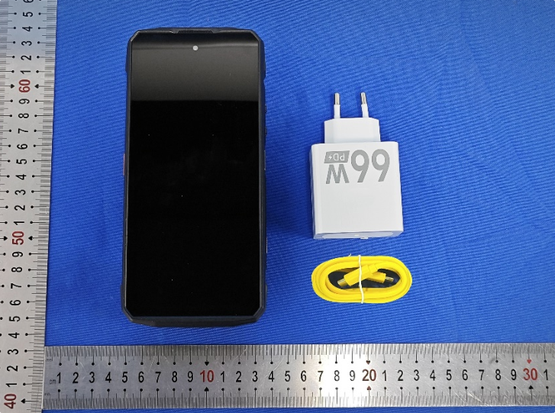

The object of the declaration described above is in conformity with the essential requirements of the relevant Union harmonization legislation:

Radio Equipment Directive RED (2014/53/EU)
The following harmonized standards and technical specifications have been applied:

Health & Safety (Article 3(1)(a)):

EN IEC 62368-1:2020+A11:2020
EN 50360:2017+A1:2023
EN 50566:2017+A1:2023
EN62209-1:2016
EN 62209-2:2010+A1:2019
EN 50663:2017
EN 62479: 2010

EMC (Article 3(1)(b)):

ETSI EN 301 489-1 V2.2.3 (2019-11)
ETSI EN 301 489-3 V2.3.2 (2023-01)
ETSI EN 301 489-17 V3.2.4 (2020-09)
ETSI EN 301 489-19 V2.1.1 (2019-04)
ETSI EN 301 489-52 V1.2.1 (2021-11)
EN 55032:2015+A11:2020
EN 55035:2017+A11:2020
EN IEC 61000-3-2:2019+A1:2021
EN 61000-3-3:2013/A2:2021/AC:2022-01

Radio Spectrum (Article 3.2):

ETSI EN 300 328 V2.2.2 (2019-07)
ETSI EN 301 893 V2.1.1 (2017-05)
ETSI EN 300 440 V2.2.1 (2018-07)
ETSI EN 301 511 V12.5.1(2017-03)
ETSI EN 301 908-1 V15.2.1(2023-01)
ETSI EN 301 908-2 V13.1.1(2020-06)
ETSI EN 301 908-13 V13.2.1(2022-02)
ETSI EN 300 330 V2.1.1 (2017-02)
ETSI EN 303 345-1 V1.1.1 (2019-06)
ETSI EN 303 345-3 V1.1.1 (2021-06)
ETSI EN 303 413 V1.2.1 (2021-04)

Notified Body Involved:
Notified Body: | Intertek Semko AB
Notified Body Number: | 0413
Notified Body Assessment Performed: | Module B+C on Article 3.1a, 3.1b, 3.2
EU-Type Examination Certificate Number: | SE-RED-2500527 Ed.1

RF Specification:

Function | Operation Frequency | Max RF output power:
BLE | 2402MHz–2480MHz | 2.04 dBm EIRP
BT(BR+EDR) | 2402MHz–2480MHz | 3.72 dBm EIRP
802.11b/g/n (HT20/40) | 802.11b/g/n (20MHz): 2412~2472MHz;  802.11n (40MHz):2422~2462MHz | 15.73 dBm EIRP
Wi-Fi 5.2G(802.11a/n20/n40/ac 20/ac40/ac80) | 802.11a/ n20/ac20:5180MHz~5240MHz  802.11 n40/ac40:5190MHz~5230MHz  802.11 ac80:5210MHz | 13.38 dBm EIRP
Wi-Fi 5.8G(802.11a/n20/n40/ac 20/ac40/ac80) | 802.11a/ n20/ac20:5745MHz~5825MHz  802.11 n40/ac40:5755MHz~5795MHz  802.11 ac80:57750MHz | 11.98 dBm EIRP
GSM/GPRS/EGPRS 900 | TX(Uplink):880M‐915MHZ;  RX(Downlink):925M‐960MHZ | 34.00 dBm
GSM/GPRS/EGPRS 1800 | TX(Uplink):1710M‐1785MHZ;  RX(Downlink):1805M‐1880MHZ | 29.00 dBm
WCDMA B I | TX(Uplink):1920-1980MHz;  RX(Downlink):2110-2170MHz | 23.00 dBm
WCDMA B VIII | TX(Uplink): 880-915MHz;  RX(Downlink):925-960MHz | 24.00 dBm
LTE FDD B1 | TX(Uplink):1920-1980MHz;  RX(Downlink):2110-2170MHz | 25.00 dBm
LTE FDD B3 | TX(Uplink) :1710-1785MHz;  RX(Downlink):1805-1880MHz | 25.00 dBm
LTE FDD B7 | TX(Uplink) :2500-2570MHz;  RX(Downlink):2620-2690MHz | 25.00 dBm
LTE FDD B8 | TX(Uplink): 880MHz to 915 MHz  RX(Downlink): 925 MHz to 960 MHz | 25.00 dBm
LTE FDD B20 | TX(Uplink): 832MHz~862MHz;  RX(Downlink):791MHz~821MHz | 25.00 dBm
LTE FDD B28 | TX(Uplink): 703 MHz to 748MHz  RX(Downlink): 758 MHz to 803 MHz | 25.00 dBm
LTE TDD B40 | Uplink & Downlink: 2300 MHz to 2400 MHz | 25.00 dBm
NFC | 13.56MHz | 32.68dBμA/m@3m
FM | Rx(Downlink): 87.5MHz~108MHz | --
GPS | Rx(Downlink): 1575.42MHz | --

Tests for SAR are conducted using standard operating positions with the device transmitting at its highest certified power level in all tested frequency bands. The maximum SAR values tested on this device when used in its normal position at the ear and when used closet othe body (at a minimum distance of 5mm/0mm) are:

Max SAR Value(W/kg)  Limitis 2.0(W/kg) for10-g | 10-gHead | 0.662
Max SAR Value(W/kg)  Limitis 2.0(W/kg) for10-g | 10-gBody | 0.896
Limitis 4.0(W/kg) for10-g | 10-gMemberDAS | 1.526

Technical file held by Manufacturer: Shenzhen Gotron Electronic CO.,LTD.

7B01, Building A, Block 1, Anhongji Tianyao Plaza, Longhua District, Shenzhen City, Guangdong Province China

Signed for and on behalf of: Shenzhen Gotron Electronic CO.,LTD.

Name and Title: | Bing Tang/Manager
Address: | 7B01, Building A, Block 1, Anhongji Tianyao Plaza, Longhua District, Shenzhen  City, Guangdong Province China



Signature of Authorized Person
2025-06-06

